Engaging towards social media vs sharing hiking photos on social media

According to our observation towards the collected data, the majority of the respondents are mostly engaging towards community features, however, this contradicts the fact that the majority of the respondents does not share their hiking photos specifically on social media. This might be due to the fact that most of the respondents do not think that the usual social media apps such as Instagram, Twitter, Facebook etc is a suitable platform to share their hiking photos. A platform that is specifically made for sharing their hiking photos would be a suitable choice for these respondents as they have a more comfortable sharing platform for others with a similar interest in hiking.

Engaging towards social media vs interacting with other hikers and photographers

Besides that, about 72% of the respondents who are more engaging towards social media are more willing to interact with other hikers and photographers. This might be due to the fact that they are more social in general, and therefore more likely to seek out social interaction towards other hikers and photographers. A platform that is specifically made for hikers and photographers with community features would be an excellent platform for hikers and photographers to reach out to others with similar interests.

Age group vs User profile

Also, about 88% of our respondents are within the age group of 18-25 years old. This correlates to the fact that most of our respondents are young adults who are students. According to the observed data, 73% of these respondents are more interested in seeing a user profile customization feature in the hiking app. This might be due to the fact that a user profile would be a good way for the users to express themselves in terms of their customization of their user profile.

Age group vs rewards system

Around 77% of our respondents who are within the age group of 18-25 years old are also more likely to be interested in seeing a reward system within a hiking app that grants users points after completing a certain task. This might be due to the fact that these respondents who are tech savvy, are familiar with these kinds of rewards systems that are implemented in other apps as well. These reward systems could motivate the users to continue using the app by giving them a sense of accomplishment and encourage them to continue using the app.

Gameplay aspects

The overall responses towards the gameplay aspects in a hiking app were uniformly distributed. However, around 76% of the respondents are still interested in seeing some gameplay aspects in a hiking app. This might be due to the fact that most of the respondents are tech savvy young adults who enjoy these features in an app.

One time pay

Based on the collected data, most of the respondents are not interested in a one-time payment to unlock app features. This might be due to the fact that the majority of our respondents are young adults, who are students and therefore do not have the financial ability to have in-app purchases unless they think it is necessary.

According to our observation towards the collected data, the majority of the respondents are mostly engaging towards community features, however, this contradicts the fact that the majority of the respondents does not share their hiking photos specifically on social media. This might be due to the fact that most of the respondents do not think that the usual social media apps such as Instagram, Twitter, Facebook etc is a suitable platform to share their hiking photos. A platform that is specifically made for sharing their hiking photos would be a suitable choice for these respondents as they have a more comfortable sharing platform for others with a similar interest in hiking. Besides that, about 72% of the respondents who are more engaging towards social media are more willing to interact with other hikers and photographers. This might be because they are more social in general, and therefore more likely to seek out social interaction towards other hikers and photographers. A platform that is specifically made for hikers and photographers with community features would be an excellent platform for them to reach out to others with similar interests. Also, about 88% of our respondents are within the age group of 18-25 years old. This correlates to the fact that most of our respondents are young adults who are students. According to the observed data, 73% of these respondents are more interested in seeing a user profile customization feature in the hiking app. This might be due to the fact that a user profile would be a good way for the users to express themselves in terms of their customization of their user profile. Around 77% of our respondents who are within the age group of 18-25 years old are also more likely to be interested in seeing a reward system within a hiking app that grants users points after completing a certain task. This might be due to the fact that these respondents who are tech savvy, are familiar with these kinds of rewards systems that are implemented in other apps as well. These reward systems could motivate the users to continue using the app by giving them a sense of accomplishment and encourage them to continue using the app. The overall responses towards the gameplay aspects in a hiking app were uniformly distributed. However, around 76% of the respondents are still interested in seeing some gameplay aspects in a hiking app. This might be due to the fact that most of the respondents are tech savvy young adults who enjoy these features in an app. Based on the collected data, most of the respondents are not interested in a one-time payment to unlock app features. This might be due to the fact that the majority of our respondents are students and therefore do not have the financial ability to have in-app purchases unless they think it is necessary.

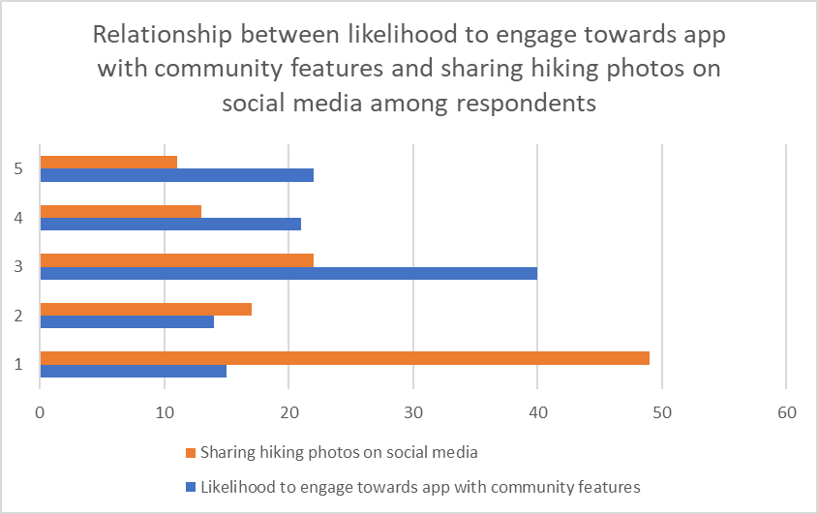

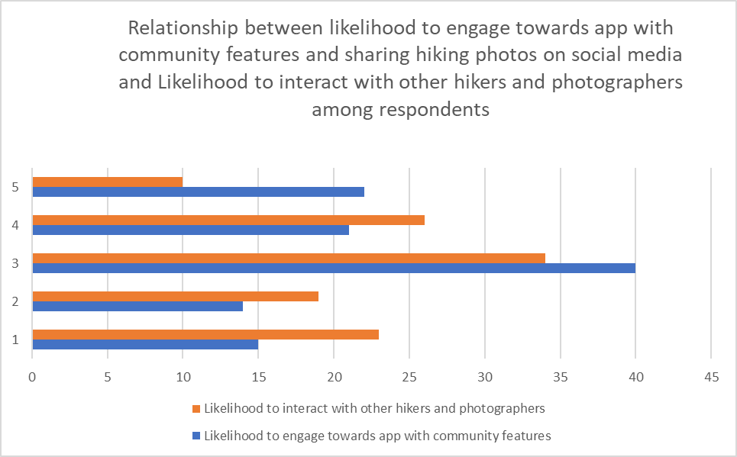

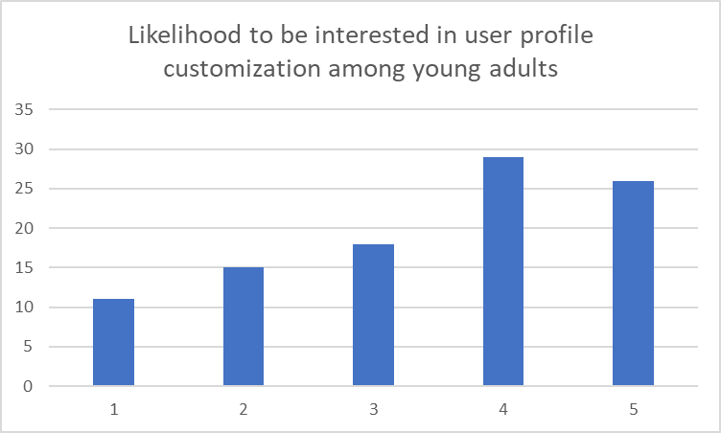

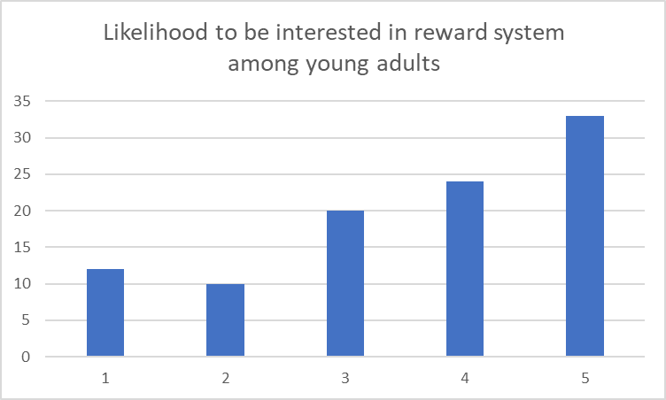

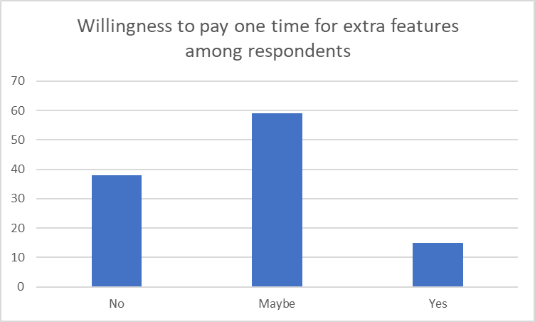

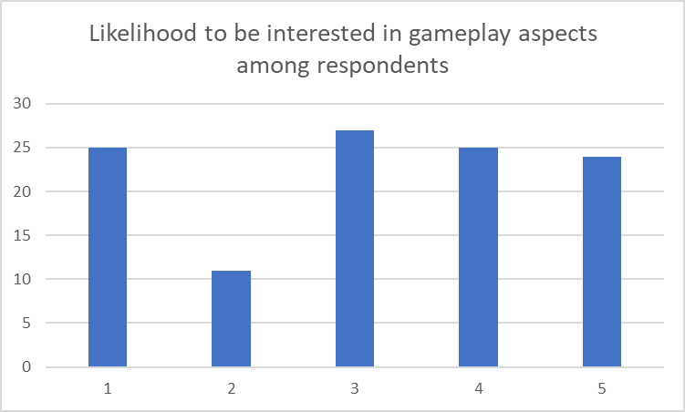

**User stories**

| Must | Should | Could | Won’t |
| --- | --- | --- | --- |
| •As Wai Kit, I want to find updated informations about hiking trails so that I can plan my hiking journey accordingly | •As Wai Kit, I want to be able to join a hiking community so that I can share my hiking photos to others.  •As Jisoo, I want to be able to find hiking communities so that I can socialise and interact with others that like hiking too. | * As Wai Kit, I want to be able to add new friends in a hiking app so that I can plan hiking trips with them * •As Jisoo, I want to be able to create a hiking user profile so that I can customise my user profile and express myself as well as viewing other people’s user profile |  |

Firstly, information based on the condition of the trails should be added and updated regularly to allow the users to be well prepared for any unexpected outcomes or dangers. For example, if the hiking trail condition is wet or unstable, the users should be pre-informed so that users can prepare special equipments or even avoid these hiking trails

Besides that, an implementation of a hiking community should be implemented to allow the users to be able to socialise and interact with others. The hiking community should be a more comfortable place for hikers to share their experiences or hiking photography with other hikers with similar interests as each other.

Additionally, a feature of adding new friends could be added in order to keep in contact with those that they have recently interacted with, or usually interact with for much convenience in planning new hiking trips as well as encouraging interaction between hikers.

Lastly, a feature regarding creating a user profile could be added in order for users to save their hiking experiences as well as expressing themselves in terms of their recent hiking activity.

**2 additional Requirements**

* Community feature to socialise with other hikers and photographers
* Including a user profile feature in the hiking app

**Analysis**

The user persona is created based on analysing the responses collected to identify common patterns and trends that have occurred in the majority of respondents. For example, based on the collected responses, the majority of the respondents are Malaysian Chinese Students within the age group of 18-25 years old. A majority of the respondents, 62.5% of the respondents have given a positive response to being interested in interacting with other hikers and photographers. By creating the user persona based on the collected responses, we can also identify the target user group of what additional features could be included in the hiking app. Therefore, the biography, motivations, goals and frustrations have revolved around this majority user group in order to provide us with sufficient information on what to be included, or the potential features that could be in the final production of the hiking app.

The user stories are created based on the majority of the collected responses from the questionnaire to prioritise the needs of the user in the development process of the apps. User stories help us understand the motivations, behaviours, goals as well as what they will be expecting from the hiking app. These expectations allow the developers to prioritise the features and functionality that must, could or should be implemented based on their importance to the users. By using the MoSCoW framework, developers can identify the importance of what features should be prioritised first before moving on to implementing other additional features in the hiking app. For example, based on the responses, we can prioritise building a hiking community function as a majority of the users who have used a hiking app in the past have brought up that the hiking app lacks community engagement. Therefore, these user stories help the developers by creating a list of additional requirements that they specify for the end product of the hiking app.

One of additional requirements that should be included in the hiking app is including a community feature in the hiking app where users can socialise with other hikers and hikers who love photography. This is because based on the collected responses, users who have used a hiking app in the past have brought up a problem where the hiking app lacks community engagement to find hiking stories or information from others, and to socialise with others. From the collected data, about 62.5% of the respondents have also given a positive response to being interested in interacting with other hikers and photographers. Therefore, a hiking app that features a community function would be a great feature for the users to interact with other hikers and hikers who are interested in photography by creating new posts, threads or even sharing photos of their hiking experiences and journey

The second requirement that should be included in the hiking app is including a user profile feature in the hiking app. Based on the collected responses from our questionnaire, about 74% of the respondents are interested in having user profile customization options. These customizations would be a great way for users to share their hiking experiences by creating posts on their profile to share their hiking experience, adding a biography to introduce themselves to others as well as adding updates to their profile. This would be a great way for the users to express themselves based on their hiking experiences, as well as getting to know more about other hikers as well.